**3d Models**

David O’Sullivan T00139303

Firstly the two Conventions that we will use for 3d models are

* Origin(0,0,0) at the centre of Mass
* Describe faces in the same direction (usually counter clock-wise)

We use the former because when we talking about scaling or rotation from the centre of mass, everything will scale or rotate equally. Imagine if we scaled from the bottom corner of a square then eventually, we would have eg. (0,0) (0,40) (40,40) (40,0) where as if we scaled from the centre of mass we would have (20,20), (20,20), (20,20), (20,20). Makes more sense and looks neater!

We describe faces of a triangle in the same direction because this allows us to give a uniform and consistent description of the shape.

**Example**

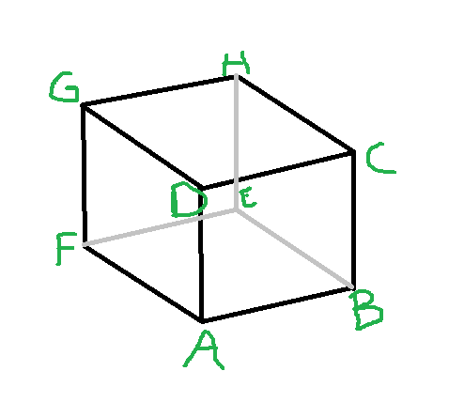

Put simply the front side (A,B,C,D) and the back side (E,F,G,H).

Using the same example we will do a vertex list and a face (index) list!

To do this we will split our faces in half (red line!). We do this because when we talk about vertices, we always deal in triangles!

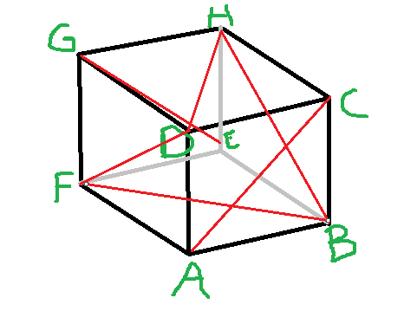

So If you remember we always talk about a point in relation to the centre of mass (the middle in this case)

So A is left of the centre of mass (-1 on the X Axis), lower than the centre of mass (-1 on the Y axis) and nearer than the centre of mass (1 on the Z Axis). Using this logic, lets fill out the table for this info! This tells us the position of our points.

**Vertex List**

|  |  |  |  |
| --- | --- | --- | --- |
| **X** | **Y** | **Z** | **VERTEX** |
| -1 | -1 | 1 | A |
| 1 | -1 | 1 | B |
| 1 | 1 | 1 | C |
| -1 | 1 | 1 | D |
| 1 | -1 | -1 | E |
| -1 | -1 | -1 | F |
| -1 | 1 | -1 | G |
| 1 | 1 | -1 | H |

Notice any patterns?

Next we are required to do a Face (index) list which describes the faces.

Remember we go anti clockwise consistently.

**Face List**

|  |  |  |
| --- | --- | --- |
| **Index** | **Shape** | **Side** |
| 0 | A C D | Front |
| 1 | A B C | Front |
| 2 | B H C | Right |
| 3 | B E H | Right |
| 4 | E G H | Back |
| 5 | E F G | Back |
| 6 | F A D | Left |
| 7 | F D G | Left |
| 8 | D H G | Top |
| 9 | D C H | Top |
| 10 | F B E | Bottom |
| 11 | F A B | Bottom |

Now all there is to do is define the texture vertex list. This is simply a flattened version of our shape put on a 2 dimensional axis. For this exercise we refer to (x,y) as (u,v).

Our left and lower most point is set to (0,0) and the upper most point on the left is (1,1)

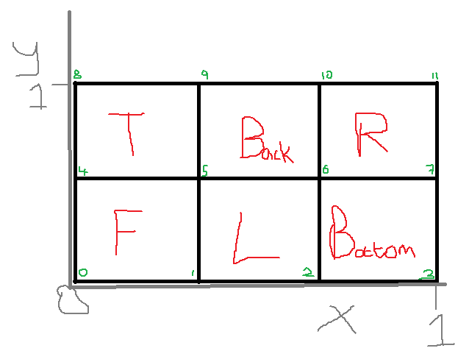

So from this, we can derive our texture vertices list!

**Texture Vertices List**

|  |  |  |
| --- | --- | --- |
| **Index** | **U** | **V** |
| 0 | 0 | 0 |
| 1 | .333 | 0 |
| 2 | .667 | 0 |
| 3 | 1 | 0 |
| 4 | 0 | .5 |
| 5 | .333 | .5 |
| 6 | .667 | .5 |
| 7 | 1 | .5 |
| 8 | 0 | 1 |
| 9 | .333 | 1 |
| 10 | .667 | 1 |
| 11 | 1 | 1 |

Notice any Patterns?